KOPPLINGSSCHEMA
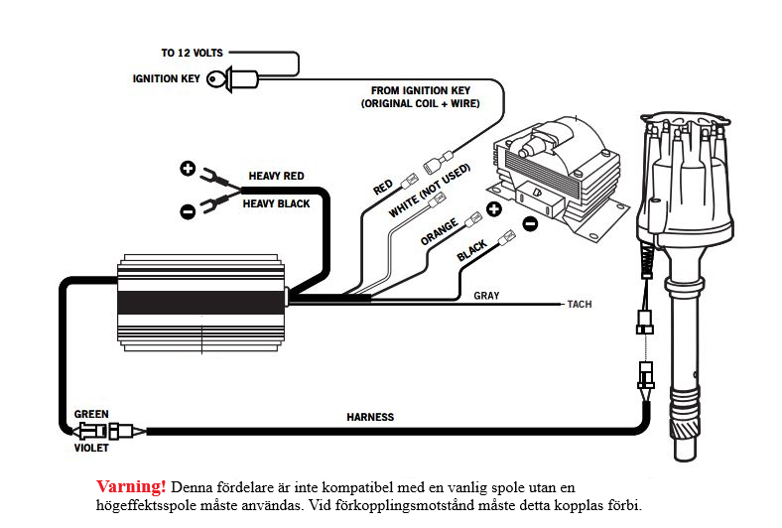

CHANGING THE ADVANCE STOP BUSHINGS
1. Remove the distributor cap and rotor.
2. Remove the locknut and washer on the bottom of the advance assembly
3. Remove the bushing and install the new one.
4. Install the washer and locknut.

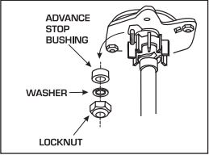

LOCKING OUT THE CENTRIFUGAL ADVANCE
1. Remove the advance components including the springs, weights and the advance stop bushing from the advance assembly.
2. Remove the roll-pin from the drive gear and remove the gear from the shaft.
3. Slide the shaft two inches out of the housing.
4. Rotate the shaft 180° and insert the advance stop bushing pin into the small hole on the advance plate
5. Install the locknut and washer to the advance stop bushing pin. This locks the advance in place.
6. Install the drive gear and roll-pin.

